Doors;

DB BAss
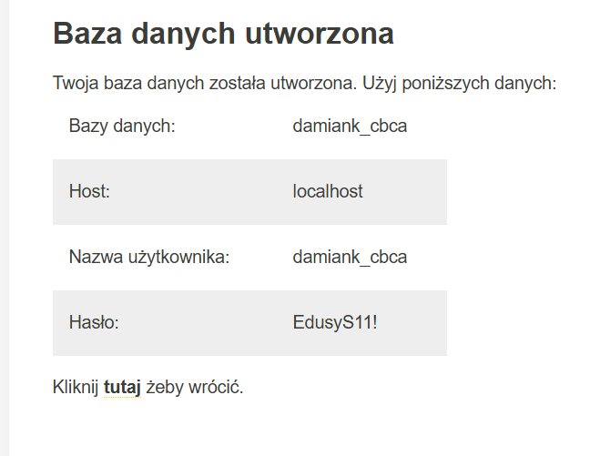

Cyberfolks
damianK lub damiank
X,2QPnjolE

WP:
cbca2025!

